California State University Fullerton

CPSC 462



Object Oriented Software Design

Use Case Model – Annex 2

for the



Tuffy Flights

System

Receive Hotel Recommendation

Fully Dressed Use Case

|  |  |  |
| --- | --- | --- |
| **Nathan Marcos** | **Jared Castaneda** | **Jawad Swed** |
| Project Member | Project Member | Project Member |
| [nathanmarcos@csu.fullerton.edu](mailto:nathanmarcos@csu.fullerton.edu) | [jaredcast@csu.fullerton.edu](mailto:jaredcast@csu.fullerton.edu) | [jawadswed@csu.fullerton.edu](mailto:jawadswed@csu.fullerton.edu) |

Revision History:

| Version | Date | Summary of Changes | Author |
| --- | --- | --- | --- |
| 1.0 | 9/14/2020 | * Initial Release | Nathan Marcos  Jared Castaneda  Jawad Swed |
| 1.1 | 9/21/2020 | * Added the highest business use case * Added the alternate use case * Added the special requirements | Nathan Marcos |
| 1.2 | 11/9/2020 | * Added both system sequence diagrams * Edited the use cases to include credit card | Nathan Marcos |
| 1.3 | 12/6/2020 | * Removed requests and returns from external system in the system sequence diagrams | Nathan Marcos |

Table of Contents

1 Use Case Description 1

1.1 Use Case Title 1

1.2 Scope 1

1.3 Category 1

1.3.1 Risks addressed 1

1.4 Level 1

1.5 Primary Actor(s) 1

1.6 Stakeholders and Interests: 1

1.6.1 Project Team 1

1.6.2 Airline Ticket Commissioner 1

1.6.3 Hotel Promoter 1

1.7 Preconditions (Entrance Criteria) 1

1.8 Success Guarantee (Exit State) 1

1.9 Main Success Scenario: 1

1.10 Extensions (Alternate paths) 2

1.11 Special Requirements: 2

1.12 Technology and Data Variations List: 3

1.13 Frequency of Occurrence: 3

1.14 Miscellaneous: 3

2 System Sequence Diagrams 4

2.1 View Hotel Advertisement 4

2.1.1 Scenario Description 4

2.1.2 System Sequence Diagram 4

2.2 Ignore Hotel Advertisement 5

2.2.1 Scenario Description 5

2.2.2 System Sequence Diagram 5

**Error! Hyperlink reference not valid.Error! Hyperlink reference not valid.Error! Hyperlink reference not valid.Error! Hyperlink reference not valid.Error! Hyperlink reference not valid.Error! Hyperlink reference not valid.Error! Hyperlink reference not valid.Error! Hyperlink reference not valid.Error! Hyperlink reference not valid.Error! Hyperlink reference not valid.Error! Hyperlink reference not valid.Error! Hyperlink reference not valid.Error! Hyperlink reference not valid.Error! Hyperlink reference not valid.Error! Hyperlink reference not valid.Error! Hyperlink reference not valid.Error! Hyperlink reference not valid.Error! Hyperlink reference not valid.Error! Hyperlink reference not valid.Error! Hyperlink reference not valid.Error! Hyperlink reference not valid.Error! Hyperlink reference not valid.Error! Hyperlink reference not valid.Error! Hyperlink reference not valid.Error! Hyperlink reference not valid.Error! Hyperlink reference not valid.Error! Hyperlink reference not valid.**

# Use Case Description

## Use Case Title

Receive Hotel Recommendation

## Scope

Tuffy Flights

## Category

Highest Business Value

### Risks addressed

1. System failure

## Level

User goal

## Primary Actor(s)

* Customer

## Stakeholders and Interests:

### Project Team

The project team wants to earn commission through the ticket sells and advertisement clicks.

### Airline Ticket Commissioner

Wants to satisfy customer interests with a user-friendly flight booking system to increase ticket sells.

### Hotel Promoter

Wants to promote a hotel on the flight booking system. Wants to increase reservation sales through interested traveling customers.

## Preconditions (Entrance Criteria)

Customer has account and is authenticated.

## Success Guarantee (Exit State)

Flight ticket sale is saved. Hotel is promoted through advertisement. Tax is applied and correctly calculated. Flight reservation log is updated. Plane ticket and receipt is generated. Commission and payment authorizations are recorded.

## Main Success Scenario:

1. Customer requests authentication to the system. System authenticates customer and responds with a flight catalog.
2. Customer requests a flight based on airline, departure dates, and arrival dates. The system responds with a filtered list of flights.
3. Customer requests a specified flight with seat preferences, meal choices, baggage, and flight number. The system responds with digital ticket(s) and cost summary and waits for payment information to be entered.
4. Customer requests to view hotel recommendation that meets the flight criteria. The system responds with a list of available hotel rooms.
5. Customer requests a hotel to be booked with the flight. The system responds with a hotel reservation code and updates the cost summary.
6. Customer requests to pay for the flight ticket and hotel room by providing payment information. The system responds with a receipt and updated flight points information.
7. Customer logs out of the system.

## Extensions (Alternate paths)

*a. At any time, if System fails:

1. Customer requests to restart. System responds with previous saved state.

1a. If System is unable respond with previous state.

1. Customer requests to save progress and exit. System responds with save confirmation and exits.

6a. If customer wants to pay with debit.

1. Customer requests to pay with debit card by entering card information and pin. System responds with a receipt.

6b. If customer wants to pay with credit.

1. Customer requests to pay with credit card by entering card information and zip code. System responds with a receipt.

6c. If customer payment is denied.

1. Customer request to pay with credit or debit card by providing card information and pin or zip code. System responds with payment declined information and the option to cancel transaction or enter new payment information.
2. Customer requests to pay with new card information by entering card information and pin or zip code. System responds with a receipt.

6d. If customer wants to pay with gift card.

1. Customer request to pay with gift card by entering gift card information and pays remaining total with debit or credit. System responds with a receipt.

6e. If customer wants to apply flight points.

1. Customer requests to apply flight points pay for flight and pays remaining total with debit or credit. System responds with a receipt.

## Special Requirements:

1. Customer receives receipt for all purchases.
2. Commission for flight sales and advertisement clicks is recorded.
3. Sales tax is applied properly.

## Technology and Data Variations List:

N/A

## Frequency of Occurrence:

100 per minute

## Miscellaneous:

N/A

# System Sequence Diagrams

## View Hotel Recommendation

### Scenario Description

The user requests to find roles, then the system responds with Customer and Administrator. The user requests to create a customer session. The system responds with a customer session. The user requests to get commands. The system responds with Search Flight, Book Flight, Show Ticket, Pay with Credit Card, Help, Log Off, and View Ad. The customer requests to search a flight. The system responds with a flight. The customer requests to view a hotel advertisement based on the flight searched. The external system responds with an ad. The customer requests to get external system commands. The system responds with Exit Ad. The customer requests to exit the ad. The external system responds with the sessionControl commands. The customer requests to log off.

### System Sequence Diagram

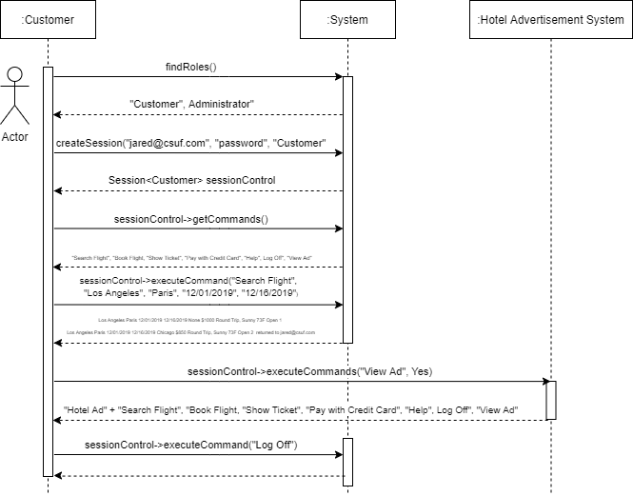

## Ignore Hotel Recommendation

### Scenario Description

The user requests to find roles, then the system responds with Customer and Administrator. The user requests to create a customer session. The system responds with a customer session. The user requests to get commands. The system responds with Search Flight, Book Flight, Show Ticket, Pay with Credit Card, Help, Log Off, and View Ad. The customer requests to search a flight. The system responds with a flight. The customer requests to not view a hotel advertisement based on the flight searched. The external system responds with the sessionControl commands. The customer requests to log off.

### System Sequence Diagram

